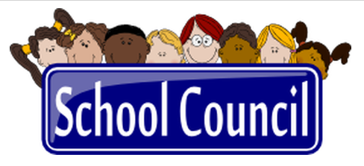

***School Council Members***

Teachers/School Staff:

1. Patrick Cook
2. Tiffany Pitts

Parents:

1. Keturiuh Pacheco
2. Rita Parkmon

Others:

1. Charles Givens
2. Vanessa Stanley
3. Sammy Jones
4. Dennis Hilliard

Administration:

1. Sharro Usry-Wilson, Ed.D
2. Kathryn Stewart

Meeting Dates: October 13, 2022 & March 14, 2023